Week 4 PSTJ
Task1:
class Solution {
public boolean halvesAreAlike(String s) {

int count1 = 0;
int count2 = 0;

int mid = s.length() / 2;

// First half
for (int i = 0; i < mid; i++) {
char ch = s.charAt(i);

if (ch == 'a' || ch == 'e' || ch == 'i' ||
ch == 'o' || ch == 'u' ||
ch == 'A' || ch == 'E' || ch == 'I' ||
ch == 'O' || ch == 'U') {

count1++;
}
}

// Second half
for (int i = mid; i < s.length(); i++) {
char ch = s.charAt(i);

if (ch == 'a' || ch == 'e' || ch == 'i' ||
ch == 'o' || ch == 'u' ||
ch == 'A' || ch == 'E' || ch == 'I' ||
ch == 'O' || ch == 'U') {

count2++;
}
}

return count1 == count2;
}
}

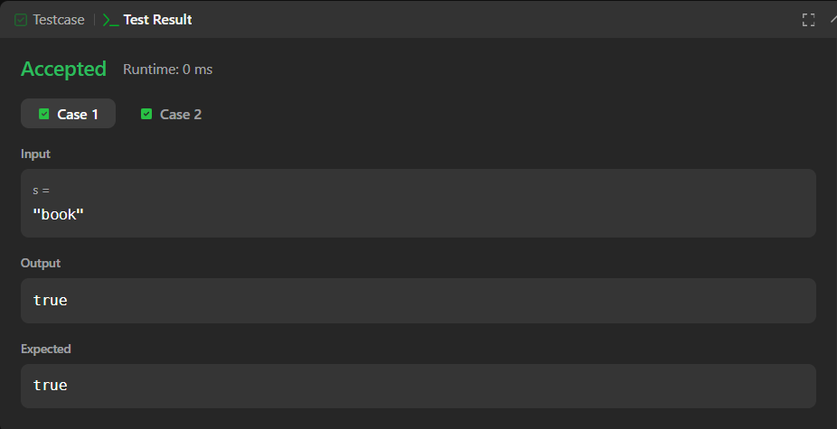
task 2:
import java.util.*;

class Codechef
{
public static void main(String[] args)
{
Scanner sc = new Scanner(System.in);

int T = sc.nextInt();

while (T-- > 0)
{
String s = sc.next();

int n = s.length();
int mid = n / 2;

int[] first = new int[26];
int[] second = new int[26];

for (int i = 0; i < mid; i++)
{
first[s.charAt(i) - 'a']++;
}

for (int i = (n + 1) / 2; i < n; i++)
{
second[s.charAt(i) - 'a']++;
}

boolean same = true;

for (int i = 0; i < 26; i++)
{
if (first[i] != second[i])
{
same = false;
break;
}
}

if (same)
System.out.println("YES");
else
System.out.println("NO");
}

sc.close();
}
}
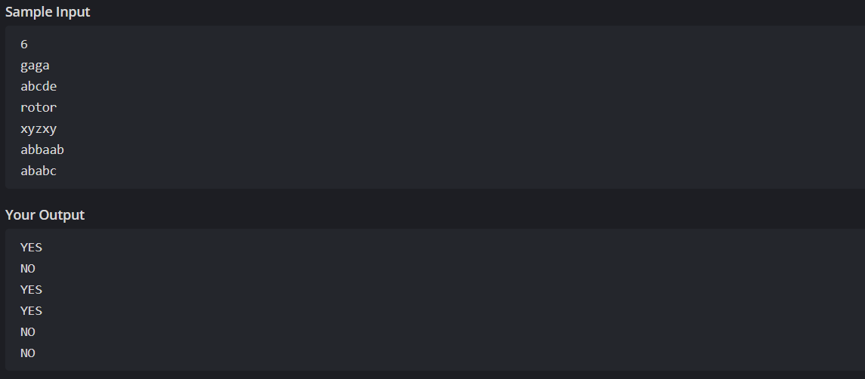
task 3:
import java.io.*;
import java.math.*;
import java.security.*;
import java.text.*;
import java.util.*;
import java.util.concurrent.*;
import java.util.regex.*;

class Result {
public static List<Integer> compareTriplets(List<Integer> a, List<Integer> b) {
int alice = 0;
int bob = 0;

for (int i = 0; i < 3; i++) {

if (a.get(i) > b.get(i)) {
alice++;
}
else if (a.get(i) < b.get(i)) {
bob++;
}
}

List<Integer> result = new ArrayList<>();

result.add(alice);
result.add(bob);

return result;
}

}

public class Solution {
public static void main(String[] args) throws IOException {
BufferedReader bufferedReader = new BufferedReader(new InputStreamReader(System.in));
BufferedWriter bufferedWriter = new BufferedWriter(new FileWriter(System.getenv("OUTPUT_PATH")));

String[] aTemp = bufferedReader.readLine().replaceAll("\\s+$", "").split(" ");

List<Integer> a = new ArrayList<>();

for (int i = 0; i < 3; i++) {
int aItem = Integer.parseInt(aTemp[i]);
a.add(aItem);
}

String[] bTemp = bufferedReader.readLine().replaceAll("\\s+$", "").split(" ");

List<Integer> b = new ArrayList<>();

for (int i = 0; i < 3; i++) {
int bItem = Integer.parseInt(bTemp[i]);
b.add(bItem);
}

List<Integer> result = Result.compareTriplets(a, b);

for (int i = 0; i < result.size(); i++) {
bufferedWriter.write(String.valueOf(result.get(i)));

if (i != result.size() - 1) {
bufferedWriter.write(" ");
}
}

bufferedWriter.newLine();

bufferedReader.close();
bufferedWriter.close();
}
}
Output:

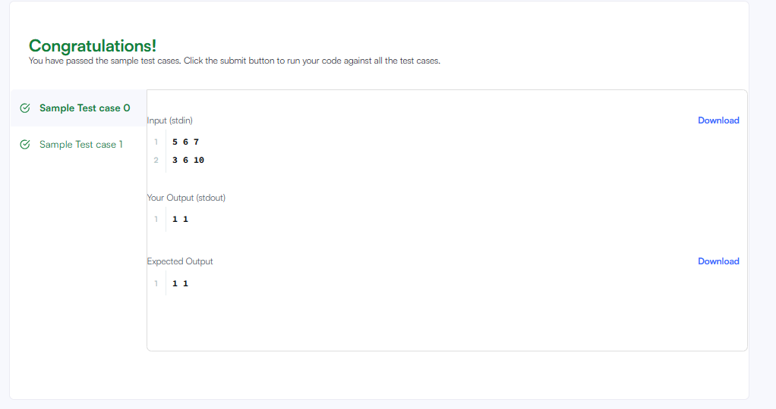
task4:
class Solution {
public boolean containsDuplicate(int[] nums) {

for (int i = 0; i < nums.length; i++) {

for (int j = i + 1; j < nums.length; j++) {

if (nums[i] == nums[j]) {
return true;
}
}
}

return false;
}
}
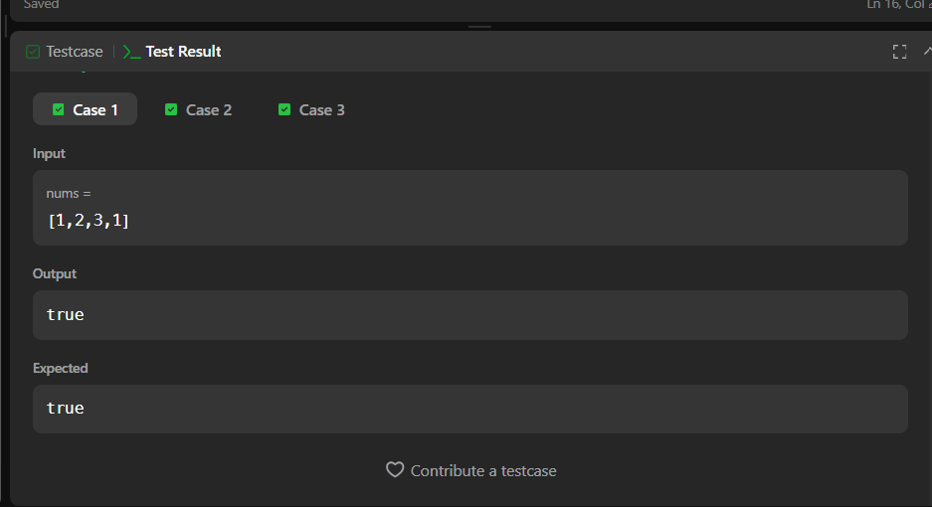
Task 5:
import java.io.*;
import java.math.*;
import java.security.*;
import java.text.*;
import java.util.*;
import java.util.concurrent.*;
import java.util.regex.*;

class Result {

/*
* Complete the 'timeConversion' function below.
*
* The function is expected to return a STRING.
* The function accepts STRING s as parameter.
*/
public static String timeConversion(String s) {

int hour = Integer.parseInt(s.substring(0, 2));
String ampm = s.substring(8, 10);

if (ampm.equals("AM")) {

if (hour == 12) {
hour = 0;
}

} else {

if (hour != 12) {
hour = hour + 12;
}
}

return String.format("%02d", hour) + s.substring(2, 8);
}
}

public class Solution {
public static void main(String[] args) throws IOException {
BufferedReader bufferedReader = new BufferedReader(new InputStreamReader(System.in));
BufferedWriter bufferedWriter = new BufferedWriter(new FileWriter(System.getenv("OUTPUT_PATH")));

String s = bufferedReader.readLine();

String result = Result.timeConversion(s);

bufferedWriter.write(result);
bufferedWriter.newLine();

bufferedReader.close();
bufferedWriter.close();
}
}

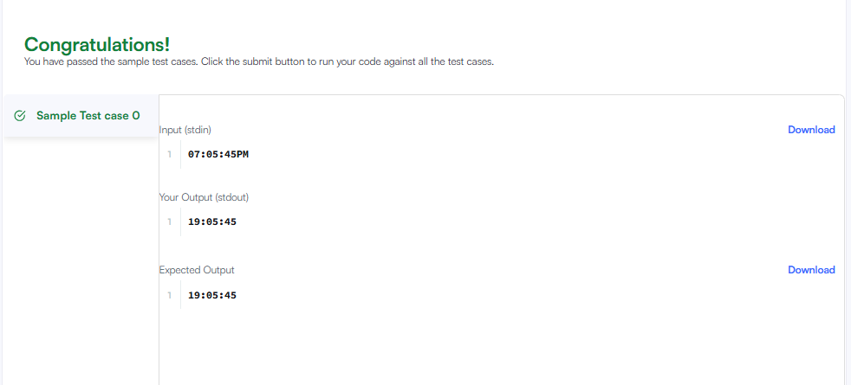
task 6:
class Solution {
public void moveZeroes(int[] nums) {

int index = 0;

// Move all non-zero elements to the front
for (int i = 0; i < nums.length; i++) {
if (nums[i] != 0) {
nums[index] = nums[i];
index++;
}
}

// Fill remaining positions with 0
while (index < nums.length) {
nums[index] = 0;
index++;
}
}
}
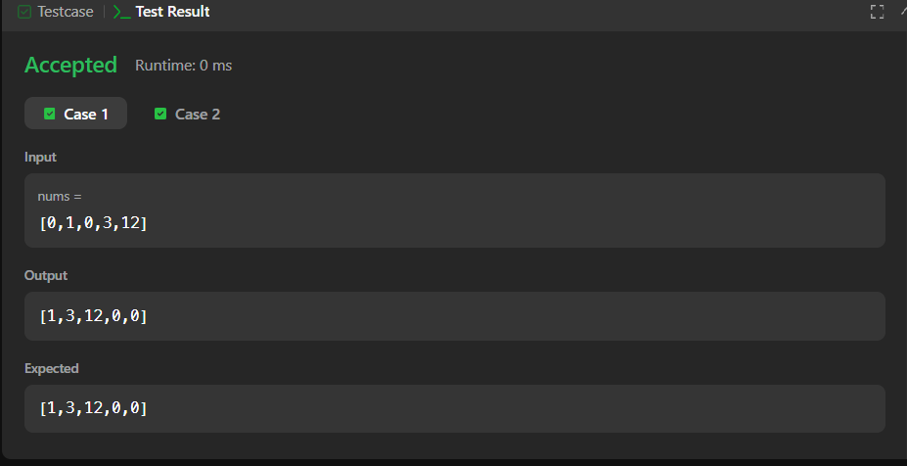
TASK 7:
import java.io.*;
import java.math.*;
import java.security.*;
import java.text.*;
import java.util.*;
import java.util.concurrent.*;
import java.util.regex.*;

class Result {

/*
* Complete the 'diagonalDifference' function below.
*
* The function is expected to return an INTEGER.
* The function accepts 2D_INTEGER_ARRAY arr as parameter.
*/

public static int diagonalDifference(List<List<Integer>> arr) {
int left = 0;
int right = 0;

for (int i = 0; i < arr.size(); i++) {
left = left + arr.get(i).get(i);
right = right + arr.get(i).get(arr.size() - 1 - i);
}

return Math.abs(left - right);
}
}

public class Solution {
public static void main(String[] args) throws IOException {
BufferedReader bufferedReader = new BufferedReader(new InputStreamReader(System.in));
BufferedWriter bufferedWriter = new BufferedWriter(new FileWriter(System.getenv("OUTPUT_PATH")));

int n = Integer.parseInt(bufferedReader.readLine().trim());

List<List<Integer>> arr = new ArrayList<>();

for (int i = 0; i < n; i++) {
String[] arrRowTempItems = bufferedReader.readLine().replaceAll("\\s+$", "").split(" ");

List<Integer> arrRowItems = new ArrayList<>();

for (int j = 0; j < n; j++) {
int arrItem = Integer.parseInt(arrRowTempItems[j]);
arrRowItems.add(arrItem);
}

arr.add(arrRowItems);
}

int result = Result.diagonalDifference(arr);

bufferedWriter.write(String.valueOf(result));
bufferedWriter.newLine();

bufferedReader.close();
bufferedWriter.close();
}
}

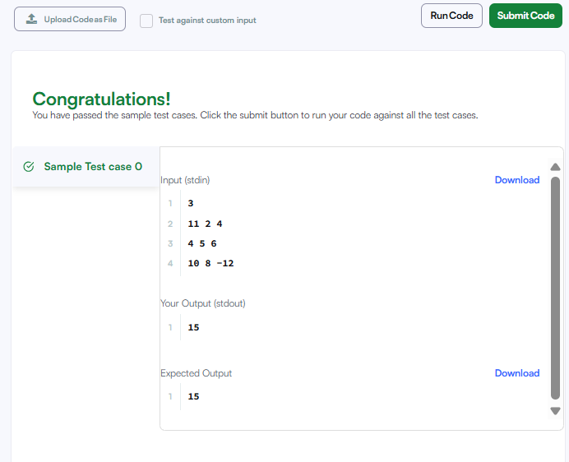
TASK 8:
class Solution {
public int[][] transpose(int[][] matrix) {

int rows = matrix.length;
int cols = matrix[0].length;

int[][] result = new int[cols][rows];

for (int i = 0; i < rows; i++) {
for (int j = 0; j < cols; j++) {
result[j][i] = matrix[i][j];
}
}

return result;
}
}
OUTPUT:
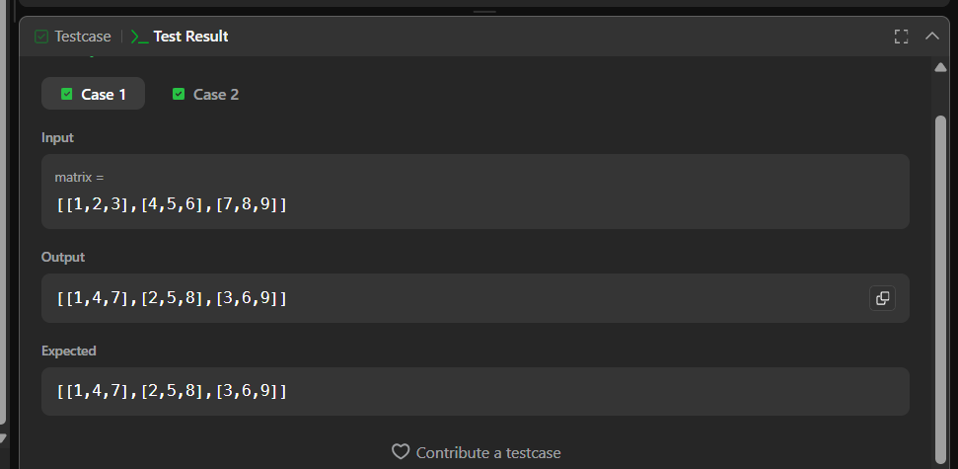
TASK 9:
class Solution {
public int[][] matrixBlockSum(int[][] mat, int k) {

int m = mat.length;
int n = mat[0].length;

int[][] answer = new int[m][n];

for (int i = 0; i < m; i++) {
for (int j = 0; j < n; j++) {

int sum = 0;

int startRow = Math.max(0, i - k);
int endRow = Math.min(m - 1, i + k);

int startCol = Math.max(0, j - k);
int endCol = Math.min(n - 1, j + k);

for (int r = startRow; r <= endRow; r++) {
for (int c = startCol; c <= endCol; c++) {
sum = sum + mat[r][c];
}
}

answer[i][j] = sum;
}
}

return answer;
}
}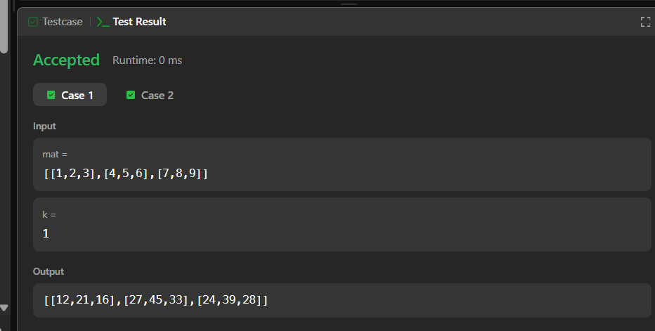

TASK 10:
import java.io.*;
import java.math.*;
import java.security.*;
import java.text.*;
import java.util.*;
import java.util.concurrent.*;
import java.util.regex.*;

class Result {

/*
* Complete the 'matrixRotation' function below.
*
* The function accepts following parameters:
* 1. 2D_INTEGER_ARRAY matrix
* 2. INTEGER r
*/

public static void matrixRotation(List<List<Integer>> matrix, int r) {
int m = matrix.size();
int n = matrix.get(0).size();

int layers = Math.min(m, n) / 2;

for (int layer = 0; layer < layers; layer++) {

List<Integer> values = new ArrayList<>();

// Top row: left -> right
for (int j = layer; j < n - layer; j++) {
values.add(matrix.get(layer).get(j));
}

// Right column: top -> bottom
for (int i = layer + 1; i < m - layer; i++) {
values.add(matrix.get(i).get(n - layer - 1));
}

// Bottom row: right -> left
for (int j = n - layer - 2; j >= layer; j--) {
values.add(matrix.get(m - layer - 1).get(j));
}

// Left column: bottom -> top
for (int i = m - layer - 2; i > layer; i--) {
values.add(matrix.get(i).get(layer));
}

// Rotate
int len = values.size();
int shift = r % len;

List<Integer> rotated = new ArrayList<>();

for (int i = shift; i < len; i++) {
rotated.add(values.get(i));
}

for (int i = 0; i < shift; i++) {
rotated.add(values.get(i));
}

int index = 0;

// Put back - top row
for (int j = layer; j < n - layer; j++) {
matrix.get(layer).set(j, rotated.get(index++));
}

// Put back - right column
for (int i = layer + 1; i < m - layer; i++) {
matrix.get(i).set(n - layer - 1, rotated.get(index++));
}

// Put back - bottom row
for (int j = n - layer - 2; j >= layer; j--) {
matrix.get(m - layer - 1).set(j, rotated.get(index++));
}

// Put back - left column
for (int i = m - layer - 2; i > layer; i--) {
matrix.get(i).set(layer, rotated.get(index++));
}
}

// Print matrix
for (int i = 0; i < m; i++) {
for (int j = 0; j < n; j++) {
System.out.print(matrix.get(i).get(j));

if (j < n - 1) {
System.out.print(" ");
}
}
System.out.println();
}
}
}

public class Solution {
public static void main(String[] args) throws IOException {
BufferedReader bufferedReader = new BufferedReader(new InputStreamReader(System.in));

String[] firstMultipleInput = bufferedReader.readLine().replaceAll("\\s+$", "").split(" ");

int m = Integer.parseInt(firstMultipleInput[0]);

int n = Integer.parseInt(firstMultipleInput[1]);

int r = Integer.parseInt(firstMultipleInput[2]);

List<List<Integer>> matrix = new ArrayList<>();

for (int i = 0; i < m; i++) {
String[] matrixRowTempItems = bufferedReader.readLine().replaceAll("\\s+$", "").split(" ");

List<Integer> matrixRowItems = new ArrayList<>();

for (int j = 0; j < n; j++) {
int matrixItem = Integer.parseInt(matrixRowTempItems[j]);
matrixRowItems.add(matrixItem);
}

matrix.add(matrixRowItems);
}

Result.matrixRotation(matrix, r);

bufferedReader.close();
}
}

